## DAILY ONLINE ACTIVITIES SUMMARY

|  |  |  |  |  |  |  |  |
| --- | --- | --- | --- | --- | --- | --- | --- |
| **Date:** | **7/06/2020** | | | | **Name:** | **Ravi K R** | |
| **Sem & Sec** | **8th- B** | | | | **USN:** | **4AL16CS076** | |
| **Online Test Summary** | | | | | | | |
| **Subject** | | **No test scheduled** | | | | | |
| **Max. Marks** | |  | | **Score** | |  | |
| **Certification Course Summary** | | | | | | | |
| **Course** | **Ultimate Java programming and certification** | | | | | | |
| **platform** | | | **Eduonix** | **Duration** | | | **10 hours** |
| **Coding Challenges** | | | | | | | |
| **Problem Statement:**  **1)** Java application program multithreaded program using Runnable interface | | | | | | | |
| **Status: Executed** | | | | | | | |
| **Uploaded the report in Github** | | | | **Yes** | | | |
| **If yes Repository name** | | | | <https://github.com/alvas-education-foundation/Ravi_kr> | | | |
| **Uploaded the report in slack** | | | | **Yes** | | | |

Online Test Details:

Certification:

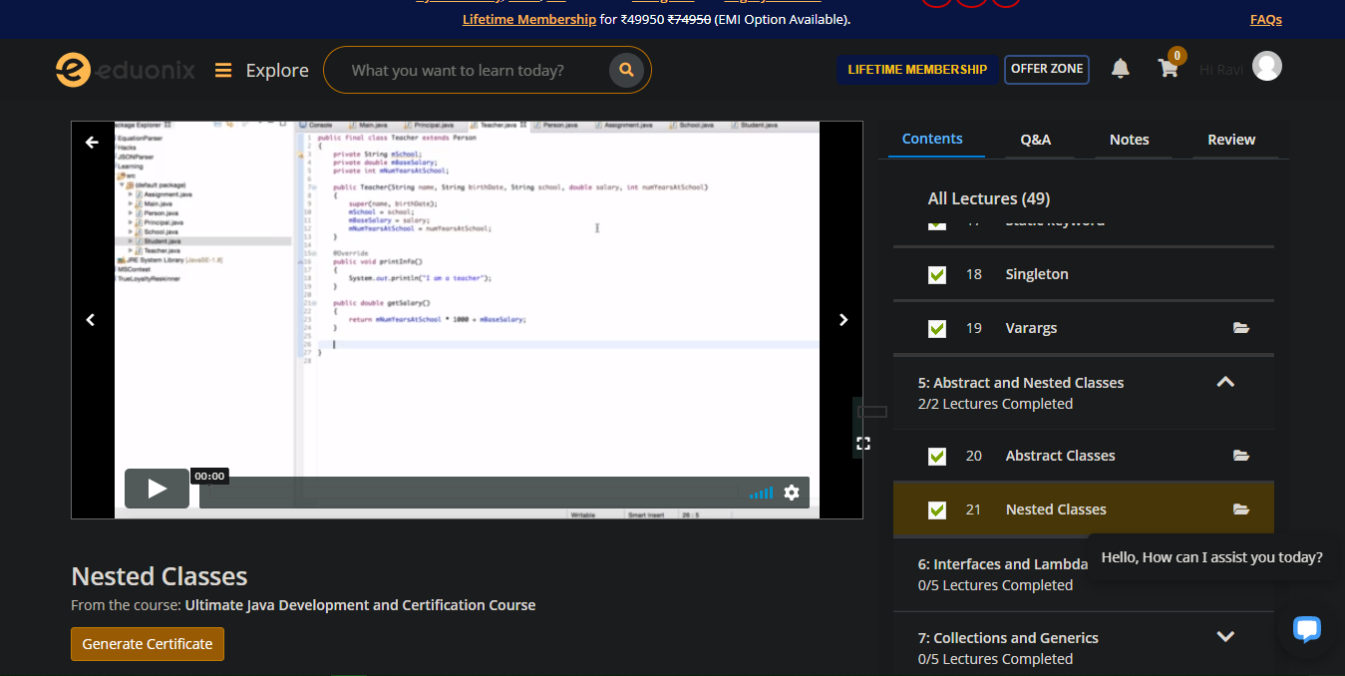

Coding Challenges Details:

**class ThreadX implements Runnable{**

**public void run( ) {**

**for(int i = 1; i <= 5; i++) {**

**System.out.println("Thread X with i = "+ i);**

**}**

**System.out.println("Exiting Thread X ...");**

**}**

**}**

**class ThreadY implements Runnable{**

**public void run( ) {**

**for(int j = 1; j <= 5; j++) {**

**System.out.println("Thread Y with j = "+ j);**

**}**

**System.out.println("Exiting Thread Y ...");**

**}**

**}**

**class ThreadZ implements Runnable{**

**public void run( ) {**

**for(int k = 1; k <= 5; k++) {**

**System.out.println("Thread Z with k = "+ k);**

**}**

**System.out.println("Exiting Thread Z ...");**

**}**

**}**

**class MultiThreadRunnable{**

**public static void main(String args[]) {**

**ThreadX x = new ThreadZ(); Thread t1 = new Thread(x);**

**ThreadY y = new ThreadY(); Thread t2 = new Thread(y);**

**ThreadZ z = new ThreadZ(); Thread t3 = new Thread(z);**

**t1.start();**

**t2.start();**

**t3.start();**

**System.out.println("... Multithreading is over ");**

**}**

**}**